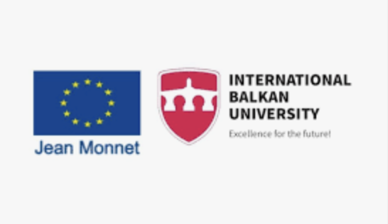
CALL FOR PAPERS
Conference organized within Jean Monnet teaching module on EU integrations and the Western Balkans (No. 101176201 – EUWB)
“Between Accession and Ambiguity: The Western Balkans and the European Project”
Faculty of Law; Faculty of Economy and Administrative Science; and Faculty of Education
International Balkan University
Skopje, North Macedonia, 18-19 June 2026
The EU accession process is at the center of EU-Western Balkans relations. The Western Balkans represent a crucial geopolitical area where the EU Enlargement policy plays a pivotal role in promoting stability, democracy, rule of law, and economic development. Deepening and widening the EU has been the ongoing imperative of the European Integration process from the very beginning. Today, the EU faces a critical juncture marked by geopolitical shifts, transnational crisis, and internal complexities, which affects the EU role and policies in the region. For geopolitical reasons, EU enlargement is high on the political agenda, but there is still a lack of readiness to welcome new members, neither institutionally nor policy wise. The next enlargement will be different from previous ones, not only because ongoing geopolitical crisis in Ukraine and the Middle East, but because the accession process has been revised with the aim to reinvigorate the transformative power of the Europeanization process.
On the other hand, EU membership for the Western Balkans states is still perceived as a route to prosperity and stability, but some critical issues still pervade the region – rule of law and democracy deficit that cannot make lasting inroads into enduring poverty, along with security challenges caused by bilateral issues. In a more competitive and unstable environment, other geopolitical actors seek a change to take advantage of the situation and the EU needs the means to better protect itself and promote its common interests. Differentiated integration (including staged accession) is nowadays discussed as a possible solution, and it has an internal and an external dimension. Envisioning the future of European integration at different tiers requires renewed understanding of the complex ratio of European integration process and EU values, as well as the specific characteristics of the Western Balkans and challenges in terms of Europeanization.
The conference “European Integration and the Western Balkans: Challenges, Opportunities, and Setbacks”, will be structured across law, economics, political science, and interdisciplinary angles. Possible topics include but are not limited to:
- Rule of Law Conditionality in EU Enlargement
- Judicial Reforms in the Western Balkans: European Standards vs. Domestic Constraints
- Fundamental Rights Protection in the EU Accession Process: Progress or Stagnation?
- Bilateral Disputes and EU Accession: Legal Obstacles to Membership
- Harmonization vs. Implementation: The Gap in EU Acquis Adoption
- Identity Documentation, Citizenship, and Minority Rights in the EU Integration Process
- Staged Accession and Differentiated Integration: Rethinking EU Membership Models
- Europeanization in Crisis: Is the EU Losing Transformative Power in the Western Balkans?
- Democratic Backsliding and EU Conditionality: Limits of External Governance
- Geopolitics of Enlargement: The Western Balkans Between the EU, Russia, and China
- Differentiated Integration and Multi-Speed Europe: Implications for Candidate Countries
- Enlargement Fatigue vs. Geopolitical Urgency: The EU’s Strategic Dilemma
- Economic Convergence or Divergence? Assessing the Western Balkans’ Readiness for the EU Single Market
- EU Funds and Economic Development: Effectiveness in Pre-Accession Contexts
- The Political Economy of Enlargement: Costs, Benefits, and Distributional Effects
- Brain Drain and Labor Mobility in the Western Balkans: A Barrier or Opportunity?
- Green Transition and Digital Transformation: Challenges for Candidate Countries
- Trade Integration and Dependency: The Western Balkans in EU Value Chains
- National Identity, Populism, and EU Integration in the Western Balkans
- Media, Disinformation, and EU Perceptions in the Western Balkans
- Multilingualism as a Core Policy of EU
- Migrant Integration and Language acquisition
- Language as a key to EU integration
- European Values in Education Policies of the Western Balkan Countries
- Intercultural Dialogue and Diversity in Western Balkan Education Policies
We invite proposals for individual paper contributions that engage empirically, conceptually, and/or normatively with these and related issues.
The working language of the conference is English.
Proposals for papers should include the title; an abstract of max. 300 words; 5–7 keywords; the identification of the main field of social science and humanities (Political Science; Law; Economics; Social Policy; Communication science, etc.); and the contact details and affiliation of the author(s).
The deadline for the submission of an abstract is 18 May 2026. Notices of acceptance will be sent out the week of 25 May 2026.
Proposals should be submitted to jmconference@ibu.edu.mk
Registration: There is no conference fee.
Authors whose abstracts have been accepted are requested submit their extended abstracts (2000 words) by the 7th June 2026. Submitting an extended abstract on time is a condition for attending the conference as a presenter. The templates will be provided to the accepted presenters.
The extended abstract will be published in conference proceedings. The selected ones will be invited to develop the full papers that will be published within the special issue on one of the peer-reviewed, no – cost, indexed International Balkan University journals, conditioned on successful peer review. Papers that fail to pass the peer-review process for indexed journals, may still be published in the conference’s proceedings.
The conference will be held in Skopje, North Macedonia at International Balkan University.
Organizing committee:
Prof. Dr. Snezana Bilic Sotirovska
Assoc. Prof. Dr. Natalija Shikova
Assist. Prof. Dr. Mare Ushkovska
Assoc. Prof. Dr. Ivan Ivanov
Assoc. Prof. Dr. Nikola Dacev
Assoc. Prof. Dr. Liza Alili Sulejmani
Assoc. Prof. Dr. Igbale Miftari Fetishi

